EMPTY_Correlational_Data_Analysis

PSYC300

## The Paper

Nisbet, E., Ortiz, M., Miller, Y., & Smith, A. (2011). The “bin Laden” effect: How American public opinion about Muslim Americans shifted in the wake of Osama bin Laden’s death. *School of Communication, Ohio State University.*

In the late 2000s, a researcher at Ohio State was conducting research on perceptions of Muslims in the US. On 1 May 2011 at 11:30 PM, then President Obama announced the death of Osama bin Laden. Recognizing the unique timestamp this represented, the researchers decided to continue the study, somewhat artificially with two groups: perceptions before and after bin Laden’s death. Participants were measured on a battery of constructs including stereotype endorsement against Muslims and support of restrictions of Muslim civil liberties.

For all variables, higher scores indicated higher levels of the construct. These data are not the original ones collected in the study—they were simulated to produce similar results. The analyses we do will not necessarily emulate the ones in the paper.

Understanding potential reasons why one may endorse limiting Muslim’s civil liberties is critical in the effort to eliminate Islamophobia (and understanding/eliminating hate toward other groups).

## The Variables

**BINLADEN:** Whether they participated *before* bin Laden was announced dead (0) or after (1).

**STEREO:** A self-report measure of the endorsement of stereotypes. (e.g., How much do you associate Tolerance vs. Fanaticism with Muslim Americans?) Four items scaled 1-5. Total: Average.

**MCIVIL:** A self-report measure of one’s support for the restriction of Muslim civil liberties (e.g., Please rate your agreement with the statement “All Muslims in the US should carry an ID card.”). Five items scaled 1-5. Total: Average.

**AGE:** The participant’s age (standardized).

**IDEO:** Political ideology (higher = conservative).

**SEX:** 0 = female, 1 = male

For all constructs, higher values = greater levels of construct.

## The Analysis

We are going to fit a model to the data with their participation group (before/after bin Laden’s death; BINLADEN) as the predictor and their endorsement of the restriction of Muslim’s civil liberties as the outcome (MCIVIL).

### Load the Required Packages

We need to read in **ggplot2** and **jtools**.

library(ggplot2)  
library(jtools)

### Read in the Data

If you’re working on Jupyter, this is in the same folder as the file so you won’t need the file path. Read the data into an object called **bl**.

bl <- read.table(file = "/Users/jjcoutts/Library/CloudStorage/GoogleDrive-jjcoutts@umd.edu/My Drive/FlashDrive/Data/CSVs/binladen.csv", header = TRUE, sep = ",")

### Generate Descriptive Statistics

Use the summary command.

summary(bl)

binladen rthreat stereo mcivil age   
 Min. :0.00 Min. :1.000 Min. :1.000 Min. :1.000 Min. :1.800   
 1st Qu.:0.00 1st Qu.:1.750 1st Qu.:2.400 1st Qu.:1.800 1st Qu.:3.700   
 Median :0.00 Median :2.500 Median :3.000 Median :2.600 Median :4.800   
 Mean :0.41 Mean :2.585 Mean :2.919 Mean :2.621 Mean :4.846   
 3rd Qu.:1.00 3rd Qu.:3.250 3rd Qu.:3.400 3rd Qu.:3.200 3rd Qu.:5.900   
 Max. :1.00 Max. :5.000 Max. :5.000 Max. :5.000 Max. :9.200   
 ideo sex   
 Min. :1.000 Min. :0.0000   
 1st Qu.:4.000 1st Qu.:0.0000   
 Median :5.000 Median :1.0000   
 Mean :5.363 Mean :0.5219   
 3rd Qu.:7.000 3rd Qu.:1.0000   
 Max. :9.000 Max. :1.0000

### Visualize the Data

What visualization would be appropriate for a dichotomous predictor and continuous outcome?

**Answer:** Boxplot; scatterplot is not appropriate because there are only two values for *X*.

ggplot(data = bl, aes(x = as.factor(binladen), y = mcivil)) +  
 geom_boxplot() +   
 labs(x = "Condition (0 = Before Death, 1 = After Death", y = "Restriction of Civil Liberties") +   
 jtools::theme_apa()

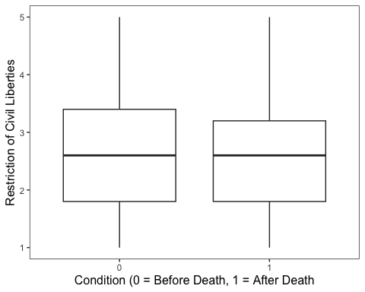

How do the assumptions look?

* Linearity: Reasonable, nothing wildly different about the boxes.
* Homogeneity of variance: The range is approximately equal for the variables.
* Normality of residuals: If you want, you can check this in the “Model” section using the command hist(resid(model_name))

### Fit the Model to the Data

What correlation coefficient should you run? (Note: The command in R is the same.)

**Answer:** Point bi-serial

# run the analysis between the binladen and mcivil variables  
cor.test(bl$binladen, bl$mcivil)

Pearson's product-moment correlation  
  
data: bl$binladen and bl$mcivil  
t = 0.050526, df = 659, p-value = 0.9597  
alternative hypothesis: true correlation is not equal to 0  
95 percent confidence interval:  
 -0.07430195 0.07821548  
sample estimates:  
 cor   
0.001968214

What are the results? Try in APA format.

**Answer:** There correlation between support of the restriction of Muslim’s civil liberties and when they participated was not significant, *r*(659) = .002, *t* = 0.051, *p* = .960.

### Exploratory Data Analysis

Run the code below if you want to explore the relationship between other variables in the dataset. You can also test out other relationships you’re interested in! (Or just ignore; the code below will render just fine.)

# exploratory data analysis  
ggplot(data = bl, aes(x = as.factor(binladen), y = stereo)) +  
 geom_boxplot() +   
 labs(x = "Condition (0 = Before Death, 1 = After Death", y = "Stereotype Endorsement") +   
 jtools::theme_apa()

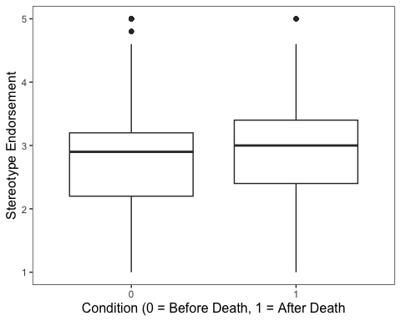

cor.test(bl$binladen, bl$stereo)

Pearson's product-moment correlation  
  
data: bl$binladen and bl$stereo  
t = 1.4045, df = 659, p-value = 0.1606  
alternative hypothesis: true correlation is not equal to 0  
95 percent confidence interval:  
 -0.0217199 0.1303456  
sample estimates:  
 cor   
0.05462959

ggplot(data = bl, aes(x = mcivil, y = stereo)) +  
 geom_point() +   
 geom_jitter() +   
 labs(x = "Restriction of Civil Liberties", y = "Stereotype Endorsement") +  
 jtools::theme_apa()

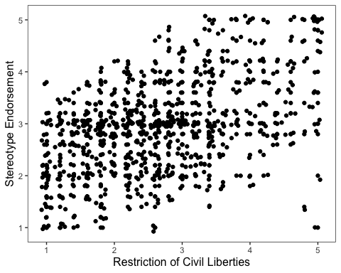

# run the correlation between the mcivil and stereo variables  
cor.test(bl$mcivil, bl$stereo)

Pearson's product-moment correlation  
  
data: bl$mcivil and bl$stereo  
t = 14.298, df = 659, p-value < 2.2e-16  
alternative hypothesis: true correlation is not equal to 0  
95 percent confidence interval:  
 0.4261536 0.5427191  
sample estimates:  
 cor   
0.4865991

## End of script